Model Summary
Specifications | Growing Method | CRT
Specifications | Dependent Variable | quality
Specifications | Independent Variables | fixedacidity, volatileacidity, citricacid, residualsugar, chlorides, freesulfurdioxide, totalsulfurdioxide, density, pH, sulphates, alcohol
Specifications | Validation | None
Specifications | Maximum Tree Depth | 20
Specifications | Minimum Cases in Parent Node | 5
Specifications | Minimum Cases in Child Node | 2
Results | Independent Variables Included | alcohol, density, chlorides, volatileacidity, citricacid, sulphates, totalsulfurdioxide, fixedacidity, pH, residualsugar, freesulfurdioxide
Results | Number of Nodes | 391
Results | Number of Terminal Nodes | 196
Results | Depth | 15

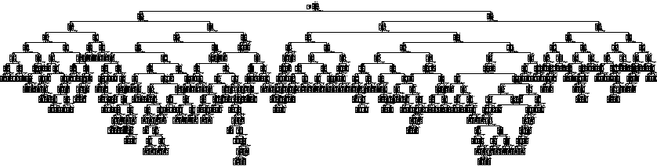

Risk
Estimate | Std. Error
.116 | .008
Growing Method: CRT
Dependent Variable: quality

Classification
Observed | Predicted
Observed | 3 | 4 | 5 | 6 | 7 | 8 | Percent Correct
3 | 2 | 0 | 5 | 2 | 1 | 0 | 20.0%
4 | 0 | 22 | 17 | 14 | 0 | 0 | 41.5%
5 | 0 | 2 | 640 | 34 | 5 | 0 | 94.0%
6 | 0 | 1 | 51 | 570 | 14 | 2 | 89.3%
7 | 0 | 0 | 7 | 23 | 168 | 1 | 84.4%
8 | 0 | 0 | 0 | 3 | 3 | 12 | 66.7%
Overall Percentage | 0.1% | 1.6% | 45.0% | 40.4% | 11.9% | 0.9% | 88.4%
Growing Method: CRT
Dependent Variable: quality

